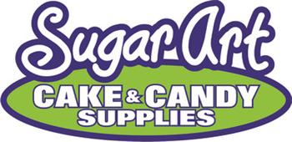
66082 Van Dyke • Washington, MI • 586.336.7777
www.SugarArtSupplies.com

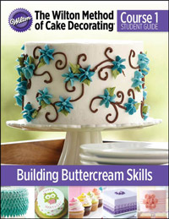

Student Supplies List – Course 1

Cake Decorating Basics Building Buttercream Skills

What to bring to Lesson 1
From Home
- 24 in. x 24 in. (60 cm x 60 cm) table cover (such as a folded bath towel)
- Scissors
- Pencil
- Toothpicks
- 6- Un-iced cupcakes
- Box or cupcake carrier for transportation
- Small bottle of water (squeeze bottle recommended)
- 3- Disposable cups or bowls (to mix and tint icing)
- Disposable cloth or paper towels
- Gallon size (10.56 in. x 10.56 in [26.8 cm x 26.8 cm]) plastic bag for cleanup

Store Products

Contents of Course 1 Kit: (if you have these products already you do not need to buy the kit)
- 8 in. Angled Spatula
- 12 -– 12in. Disposable Decorating Bags (uncut)
- 4 – Standard Couplers
- Decorating Tips: 1, 3, 12, 16, 18, 21, 1M, 104, 352, 2D, 233 and 230
- Practice Board with practice sheets
- 6 – 15 Parchment Triangles
- Decorator Paint Brush
- 1.5 inch Flower Nail
- Course 1 Student Guide
Other Products:
- Icing Colors (at least two colors)
- White Ready-to-Use Decorator Icing (16 oz. [450 g])

