

**66082 Van Dyke • Washington, MI • 586.336.7777**

[**www.SugarArtSupplies.com**](http://www.SugarArtSupplies.com)

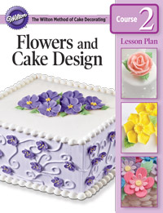

**Student Supplies List – Course 2**

**Cake Decorating Flower and Cake Design**

**What to bring to Lesson 1**

* Flowers and Cake Design Student Kit
* 1 Package [Wilton Ready-To-Use Gum Paste](http://www.wilton.com/store/site/product.cfm?sku=707-130)
* 1 Package [Wilton Neon Fondant](http://www.wilton.com/store/site/product.cfm?sku=710-446)
* [9” Rolling Pin with spacer rings](http://www.wilton.com/store/site/product.cfm?sku=1907-1205)
* [Tapered Spatula](http://www.wilton.com/store/site/department.cfm?dc=4.14)
* [Angled Spatula](http://www.wilton.com/store/site/department.cfm?dc=4.14)
* Practice Board
* Pen or Pencil
* Box to take home flowers
* Apron
* Scissors
* 2 tablespoons white vegetable shortening
* Measuring spoons (1 tablespoon, 1/4 teaspoon)
* 1 tablespoon cornstarch
* 1 tablespoon powder sugar
* 5 quart-size plastic zipper food storage bags
* 1 gallon-size plastic zipper food storage bag
* Plastic wrap
* Damp cloth
* Small container with about 1/4 cup water
* Small container with tight-fitting lid for gum-glue adhesive